Cirrus GED RMCS Manual Revenue Recognition Interface

***Modified BIP for Country-***

***Developer Name and SSO:*** *<Chundi, Venkata Ramachandra Karthik & 223074237>*

***Delivered Date:*** *REL-084 Emergency Release*

***Project Name:*** Fusion Clone and Convey

***Project Manager:*** *<Kilaru, Seshagiri & 210073716>*

***Team Name:***Fusion Clone and Convey

***Technical Team Lead:*** *<Chundi, Venkata Ramachandra Karthik & 223074237>*

***Functional Team Lead:*** *<Kilaru, Seshagiri & 210073716>*

***AHA Request id:*** *NA*

***Functional Owner****: <Kilaru, Seshagiri & 210073716>*

***Functional Consultant:*** *<Kilaru, Seshagiri & 210073716>*

***Peer Reviewed by:*** *<Dsouza, Richard & 503270420>*

***Peer Review Comments:*** *Fixed*

***Peer Review Passed*:** Yes

**If Peer Review is not passed then Reason:** N/A

**Global Component (applicable to GED/All countries):** No

Sends file to GXS?: No

***Approval History:***

***Is Tested in UAT****: Yes/No/NA: NA*

*Yes ,Attach UAT Sign Off :NA*

***Is it an Integration:*** *No*

*Yes,Attach Third Party Sign Off :No*

***Is TRB approved?*** *No*

*Yes ,Attach TRB Sign Off :Attached*

***Is new job scheduling required in Automic tool***: No

If Yes then Have you informed Fovenyi, Zsolt (GE Corporate) [zsolt.fovenyi@ge.com](mailto:zsolt.fovenyi@ge.com): N/A

***Is any parameter update/addition done to scheduled job in Automic tool***:No

If Yes then Have you informed Fovenyi, Zsolt (GE Corporate) <[zsolt.fovenyi@ge.com](mailto:zsolt.fovenyi@ge.com)> / Park, Jonghun (GE Corporate) <jonghun.park@ge.com> : N/A

***Component #***

***Brief Description:* (Release Number – 084 Emergency Release)**

updated bursting logic for file delivery from Fusion to other systems no longer involves the utilization of the profile option.

***SVN Code Path:***

SVN\branches\Releases\ QA Completed\ REL-084-Jan-2024\Emergency Release \Cirrus\Code

***SVN Document Path:***

SVN\branches\Releases\ QA Completed\ REL-084-Jan-2024\Emergency Release \Cirrus\Documentation

***SVN Migration Document Path:***

SVN\branches\Releases\ QA Completed\ REL-084-Jan-2024\Emergency Release \Cirrus\Documentation\Migration Documents

***Attachments*:** *Attach the scripts, MD documentation, Implementation instructions and Sign off etc., which are required to migrate.*

*Below is the list of components that are placed in SVN and needs to migrate in sequential manner:*

***Code Path:***

SVN\branches\Releases\ QA Completed\ REL-084-Jan-2024\Emergency Release \Cirrus\Code

|  |  |
| --- | --- |
| 1. Cirrus GED RMCS Manual Revenue Recognition DM.xdmz   *Below is the list of documents’ that are placed in SVN and used to migrate*  ***Document Path:***  SVN\branches\Releases \ QA Completed\ REL-084-Jan-2024\Emergency Release \Cirrus\Documentation   1. MD70 Cirrus GED RMCS Manual Revenue Recognition Interface.docx   ***Migration Document Path:***  SVN\branches\Releases\WIP\REL-077-JUN-2023\10-JUN-2023\Cirrus\Documentation\Migration Documents   1. MD120 Cirrus GED RMCS Manual Revenue Recognition Interface.docx |  |
|  |  |

**Migration Instructions**

**1.** Cirrus GED RMCS Manual Revenue Recognition DM.xdmz

1. Click on Navigator -> Report and Analytics

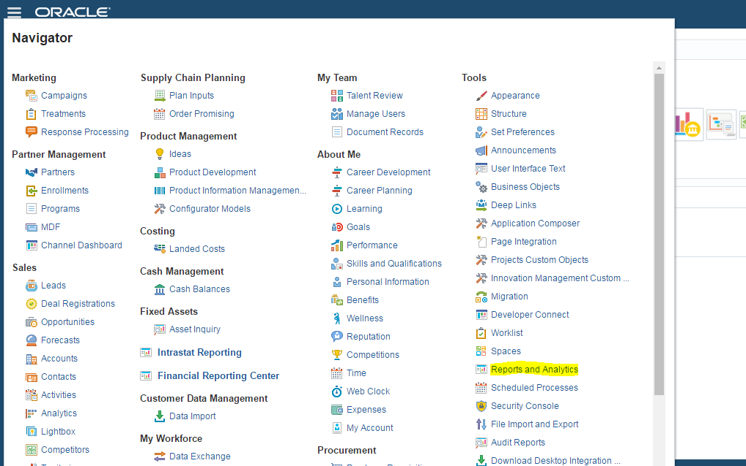

1. Click on Browse Catalog

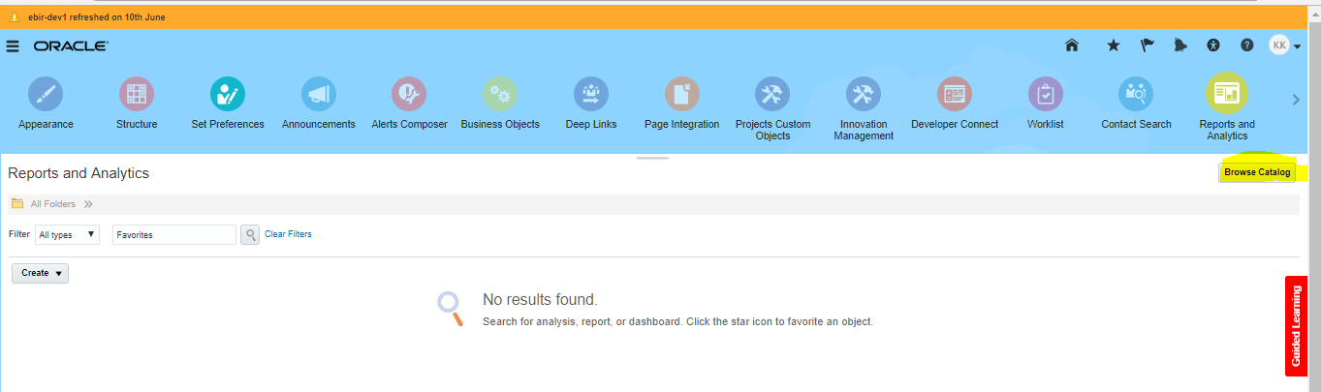

1. Replace “analytics/saw.dll?catalog” in the URL with xmlpserver and press enter. Click on Catalog

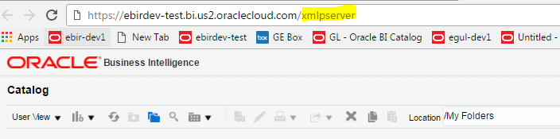

1. Navigate to Shared Folders 🡪 Custom 🡪 GED RMCS 🡪 RMCS 🡪Data Model
2. Download and take a backup of Cirrus GED RMCS Manual Revenue Recognition DM.xdmz and overwrite existing file.

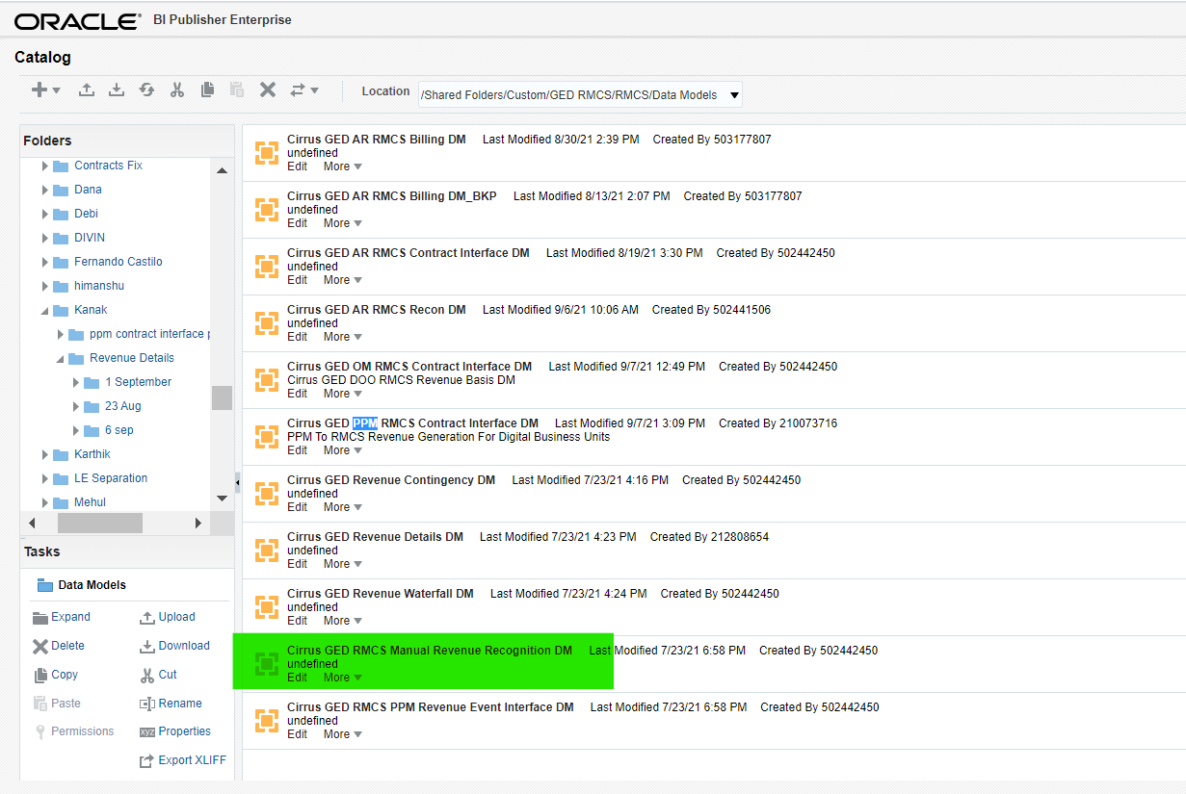

1. Upload ‘Cirrus GED RMCS Manual Revenue Recognition DM.xdmz’ file from to your local machine.
2. Window will show the message “Uploading” Please wait for the process to complete.

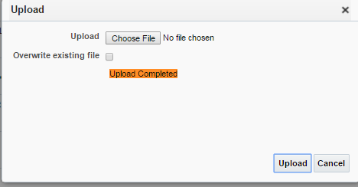

**Evaluate the Migrated Objects:**

Please ensure the migrated object is valid in below path

1. Custom 🡪 GED RMCS 🡪 RMCS 🡪 Data Model

Cirrus GED RMCS Manual Revenue Recognition DM.xdmz